Chapter 9

Layout Decisions

**Background**

Layout can be a fun topic because students can easily relate to many of the concepts covered, particularly for retail and office layouts. Coverage of the job shop, work cell, and repetitive layouts, in particular, nicely ties back to previous sections of the book that touched on those as operations strategies. Layout also includes a significant human element (both employees and customers), which can lead to a host of creative and interesting design issues. The seven layout strategies covered in this chapter are all very different from each other, and they all have their unique characteristics that should be unveiled during the lecture.

**Class Discussion Ideas**

1. Choose a local grocery store or large discount store with which most students should be familiar. Have the students identify features of the layout of that store. Does the store employ any of the five retail layout strategies identified in Slide 9-23? As consumers, do the students have any positive or negative impressions about the layout?

2. Instructors could ask students to identify three or so local restaurants and then comment on the respective layouts. What layout features stand out? Which layout features seem to be in place for efficiency vs. aesthetics? Is there anything that is not appealing? Does something about the layout in particular cause the students to choose that restaurant over others?

3. Have the students comment on the layout of the student union building. Is it functional? Is it comfortable? Are students drawn to it and want to spend time there? Is there anything that should be changed?

**Active Classroom Learning Exercises**

1. Have the students split into seven groups, one for each of the seven basic layout types described in the text. Assign a local organization for each group that exhibits the associated layout. (The instructor may need to provide some photos or drawings if students are not be familiar with their assigned company.) Have the groups formulate an explanation as to why their firm’s layout choice is appropriate (or not) given their business and apparent strategy. What layout features stand out? Have each group present its findings to the class.

2. Most universities have some area crying out for attention to the layout. Select such a spot and have the student groups prepare a proposed layout change based on the material presented in the chapter. Have each group present its findings to the class for comparison purposes.

**Company Videos**

1. *Layout at Arnold Palmer Hospital’s New Facility (9:30)*

When Arnold Palmer Hospital built a brand new women and baby care facility across the street from its current location, the staff had the opportunity to design a fresh layout to optimize efficiency and patient comfort. Management conducted extensive customer surveys to determine what patients liked and did not like about the current facility. This was followed up with extensive employee involvement incorporating 35 user groups and over 1000 meetings. The resulting layout looks very much like a work cell in a manufacturing facility (a “pod design”). The pod design saved 20% of nurse walking time during the day. The neonatal unit was designed with reduced noise and light as compared to the old facility, with the astounding impact of babies spending fewer days on ventilators, growing faster, and needing shorter overall stays in the hospital. Here, layout truly made an impact on the health of customers.

Prior to showing the video, instructors might ask the students to think about layout considerations when they either stayed in or visited someone in the hospital. What was comfortable/efficient vs. uncomfortable/inefficient? Afterwards, discussion might cover some of these issues, and compare them to what Arnold Palmer Hospital has attempted. Other discussion avenues might explore, for example, what other types of service businesses might be well-served by switching to a pod design. Alternatively, students could be asked about layout features in other service businesses that were very customer-friendly (for example, comfortable waiting rooms with internet access and nearby restrooms, lines at theme parks that have television monitors with interesting programming, etc.).

2. *Facility Layout at Wheeled Coach Ambulance (7:03)*

To manufacture ambulances, Wheeled Coach employs a combination of five parallel assembly lines fed by work cells. The work cells perform all of the pre-assembly work, such as painting, carpentry, and electrical wiring preparation. The key layout concept for management at Wheeled Coach is *proximity*. In other words, support items, support functions, and support materials should be placed as close as possible to the associated manufacturing processes. Management strives to eliminate distances and heighten communication by eliminating physical barriers. Vehicles spend eight days on the assembly lines themselves. Assembly line workers move from working on one line to the next as human resource needs dictate. Good layout strategies have helped the firm reduce its throughput times.

Prior to showing the video, instructors might ask students to think about everything that might be involved in manufacturing an ambulance. How might they set up such a production system? Afterwards, discussion might try to compare and contrast producing large-volume automobiles vs. producing very customized ambulances. Would an automobile assembly plant have use for as many (or any) work cells as Wheeled Coach has? How long do the students think that task times might be in the ambulance factory (probably quite long) vs. an auto factory (maybe 60 seconds and pulled by a moving conveyor system). Another discussion stream might focus on what assembly plants can do in terms of layout to make things as comfortable or efficient as possible for the workers. Have any students worked in a manufacturing plant? What layout features were useful, and what might have been improved?

**Cinematic Ticklers**

1. *The Crocodile Hunter, Episode 35: “Graham’s Revenge” (Steve Irwin), Animal Planet, Discovery Channel, May 13, 2001*

This episode has several scenes where the Australia Zoo staff is preparing crocodile ponds to host new tenants and where crocodiles are being transferred to new locations. One humorous scene shows two crocodiles slamming their heads together as they fight to take control of their new territory. Another scene shows a crocodile almost biting Steve’s foot off as the staff tries to place the reptile in a box for transport. The set of clips can end where Steve is feeding Graham in his brand new living area in front of a big crowd—Steve nearly slips right in front of the crocodile and states, “The crowd loves it when I nearly die.” All of these scenes have some relationship to the construction issues involved in rearranging a facility, along with the personnel issues and attitudes that can arise. Personal space at the office is important to many people, and they often get stressed when asked to change.

2. *Office Space (Ron Livingston and Jennifer Aniston), 20th Century Fox, 1999*

A recurring theme in this comedy is the treatment of a particular employee that nobody seems to want to have around. The boss keeps moving him to worse and worse work space until he finally ends up in a closet far away from everyone.

**Presentation Slides**

INTRODUCTION (9-1 through 9-10)

Slides 8-10: McDonald’s is a nice example to cover because most students are intimately familiar with the restaurant. Slides 8 and 9 cover the seven major innovations that McDonald’s has implemented over the years, noting that six of these are layout decisions. The newest innovation (Slide 10) involves a hefty setup cost and, along with children’s play areas, takes the restaurant beyond a simple “grab food, eat quickly, and go” model. A short class discussion could gauge student reactions to, in particular, the “linger zone” and the “flexible zone.”



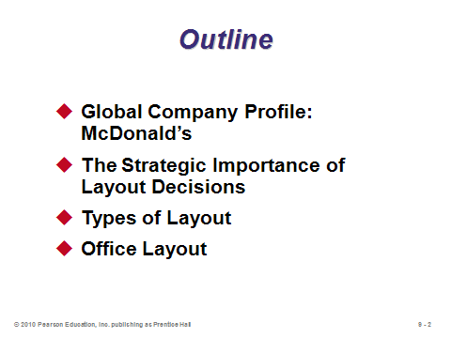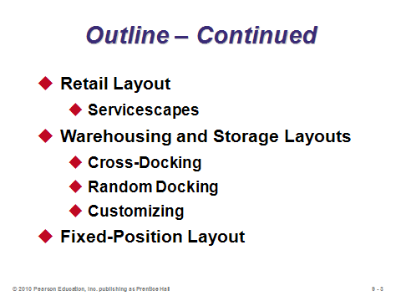

**9-1 9-2 9-3**

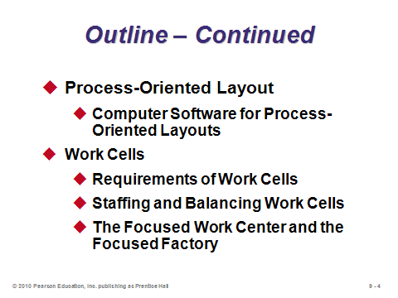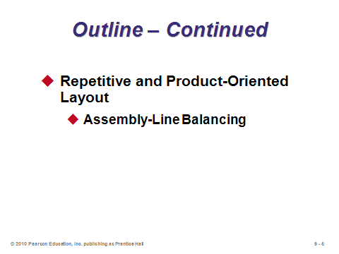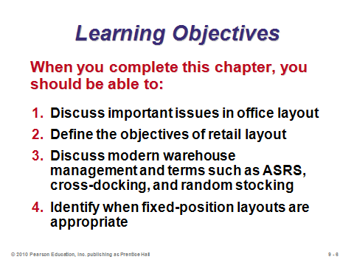

**9-4 9-5 9-6**

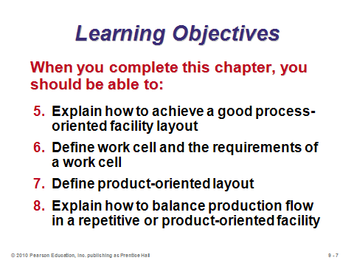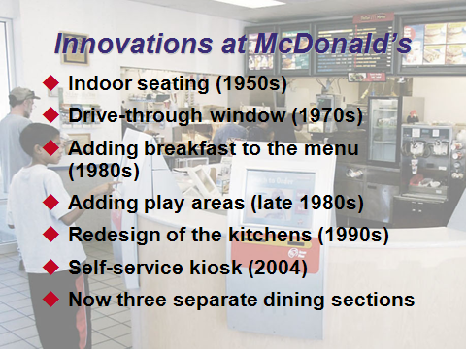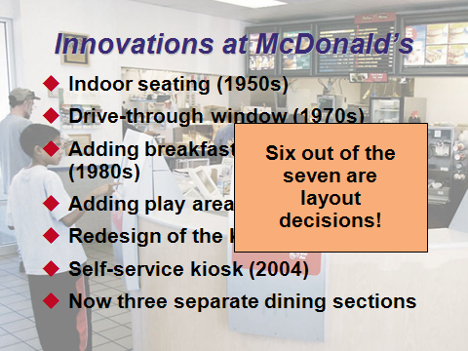

**9-7 9-8 9-9**

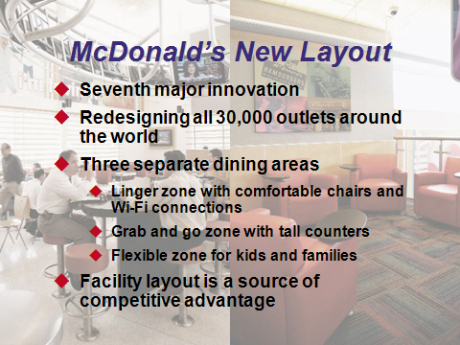

**9-10**

THE STRATEGIC IMPORTANCE OF LAYOUT DECISIONS (9-11 through 9-12)

Slide 12: Layout design is interesting because it sometimes balances very different objectives of efficiency vs. making humans (workers and/or customers) happy. Outstanding layout features can change employee or customer attitudes and perceptions, potentially producing more productive workers and/or happier customers who may purchase more and remain loyal.

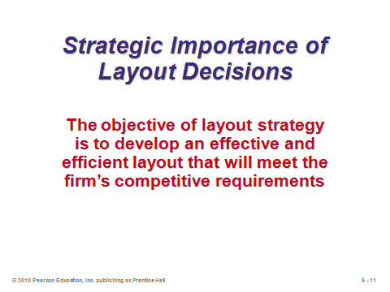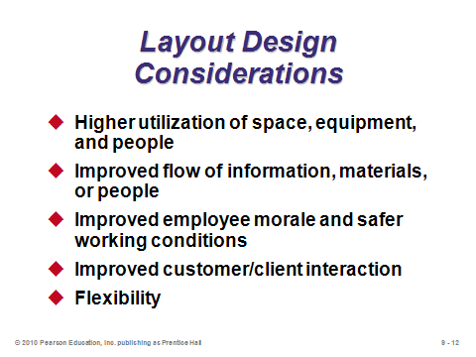

**9-11 9-12**

TYPES OF LAYOUT (9-13 through 9-19)

Slide 13: The seven layout types identified in this slide are all covered in detail in this chapter.

Slides 14-16: These slides provide a brief description of each type of layout.

Slides 17-18: These slides reproduce Table 9.1 from the text. The objectives are very different, and they drive the respective solution approaches involved. A short class discussion could go through the list, identifying features of some of the examples listed or instructors’/students’ own examples of each layout type. It can be interesting to record what students have noticed about layout decisions based on their own experiences as workers or customers and then to see, as the lecture continues, which features were identified and which were perhaps not.

Slide 19: This can be a good place to point out that, while mathematical models and software applications do exist for the facility layout problem, many actual implementations are based more on art than science. Regardless, good layouts typically consider all of the factors identified in this slide. Instructors might point out that a major reason why layouts have become more *open* (fewer offices, shorter cubical walls, etc.) over the years has been to increase information flow (communication) among workers (sometimes to the dismay of those who like to work in private).

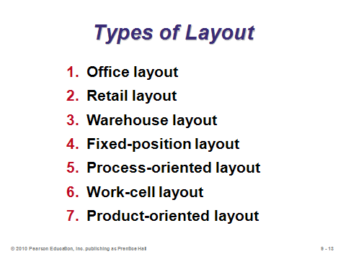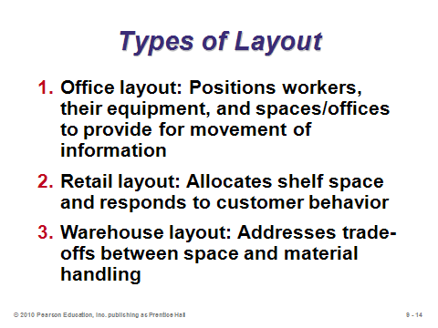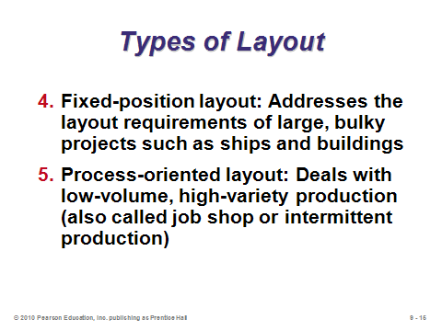

**9-13 9-14 9-15**

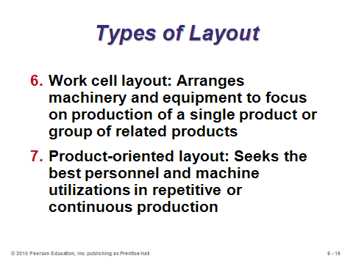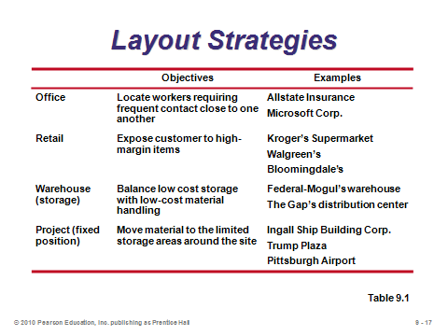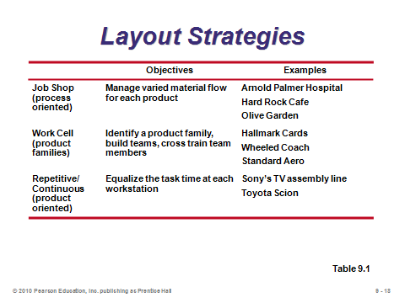

**9-16 9-17 9-18**

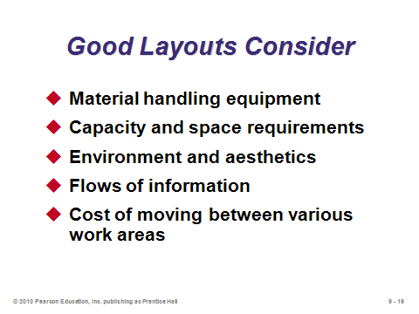

**9-19**

OFFICE LAYOUT (9-20 through 9-21)

Slide 20: The use of modular cubicles and flexible furniture allows office managers to rather easily alter layouts as conditions and personnel change.

Slide 21: When showing the relationship chart, instructors can add some examples such as the boss wanting to be near the bathroom, the senior manager wanting a lakeside view, or the couple who broke up wanting to be as far away from each other as possible. Software has existed for a long time that can provide good layouts based on a relationship chart—this is particularly useful for layout decisions involving many employees and/or departments. Instructors might point out that the development of a relationship chart can be a good way to involve employees in the design process. Let each employee provide input, at least concerning the departments or people relevant to them, and base the final chart on aggregate employee perceptions and desires.

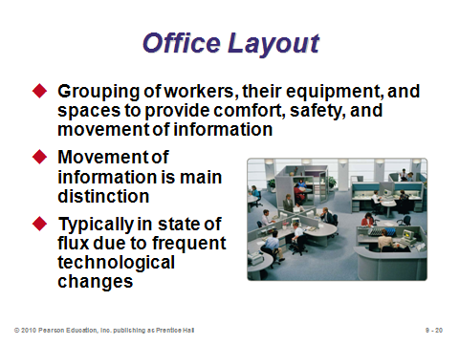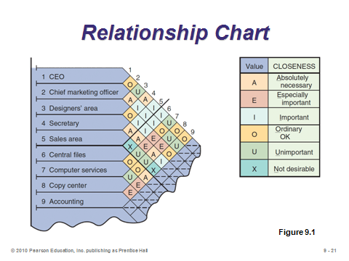

**9-20 9-21**

RETAIL LAYOUT (9-22 through 9-27)

Slides 22-23: Retail layout is fascinating due to the significant influence of consumer behavior. This represents one area of business where academic research has had a tremendous impact. As seen in the list on Slide 23, an important reason for the location of some items is to get consumers to look at other, perhaps less popular, items along the way. High-impulse items are sometimes located “front and center” in the store, and others are located in the checkout line, enticing customers to put them in their basket even though they had no intention of purchasing such products upon entering the store.

Slide 24: Figure 9.2 illustrates the intentional placing of dairy and bakery on opposite ends of the store to cause customers to pass by many other products on their way from one staple product area to the other.

Slide 25: Slotting fees are a somewhat controversial mechanism that retailers employ to allow manufacturers to put products on the store shelves. Retailer power has enabled this practice, but it provides a particular hindrance to small suppliers. Some suppliers may try direct selling through the internet to avoid paying such a fee. Interestingly, despite its reputation of being tough on suppliers, the world’s biggest retailer Wal-Mart does not demand slotting fees.

Slide 26: This picture is not in the text. It demonstrates how computerized tools can be used to suggest to store employees exactly which products to place across the shelves.

Slide 27: A servicescape describes the physical surroundings in which a service is delivered and how the surroundings have a humanistic effect on customers and employees. Firms should consider the elements identified in this slide in order to design a good service layout.

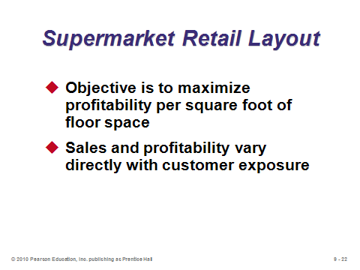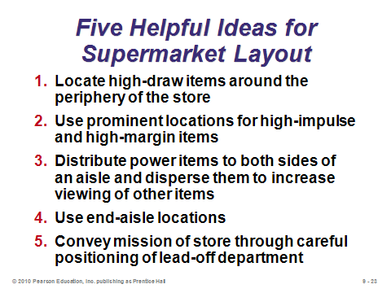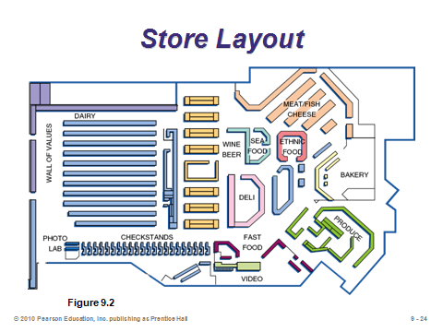

**9-22 9-23 9-24**

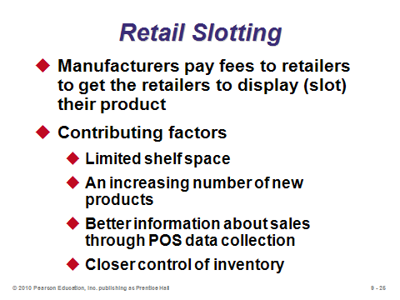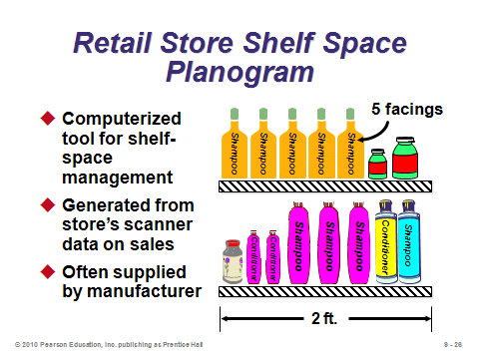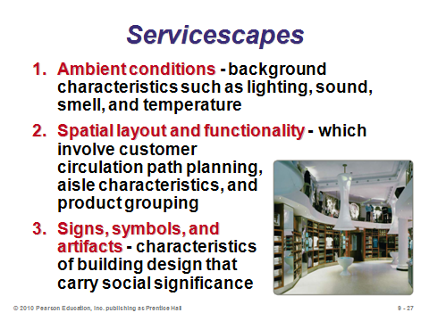

**9-25 9-26 9-27**

WAREHOUSING AND STORAGE LAYOUTS (9-28 through 9-35)

Slides 28-30: An interesting feature of warehouses is that most storage and space considerations are three-dimensional in nature (east-west, north-south, and up). There can be definite safety considerations about the vertical dimension, e.g., it’s better to put toilet paper than televisions on the top shelf. In general, high-volume items should be placed closest to the docks to minimize material handling costs; however, items that take up a lot of space should be placed further from the docks so that other items can be retrieved quicker (i.e., there is an opportunity cost for taking up a lot of space near the dock with only one type of item). (See Other Supplementary Material for the formulation of the one-dock warehouse problem along these lines.) The first bullet on Slide 30 demonstrates one of the benefits of component commonality. Essentially, more and more space is wasted when stocking more and more different items, as space needs to be allocated for each item type. The picture in this slide provides a dramatic demonstration of an ASRS implemented at a parking garage in Germany. This garage handles the same number of cars using only 20% of the space of a normal garage—and no drivers are needed (along with their associated driving accident risks)! The cars are all retrieved via a huge crane.

Slide 31: Cross-docking is considered to be an enlightened approach to distribution. The warehouse actually does not store anything longer than a few hours, so it acts as a transfer point rather than as a traditional warehouse. Cross-docking may work particularly well for fast-moving items requiring daily deliveries.

Slide 32: Random stocking can save a significant amount of inventory space, particularly for firms storing many different items. The computer information systems requirements are significant.

Slide 33: In some sense the opposite of cross-docking, *customizing* suggests that warehouses should not only store goods but should also add some value to them. This slide identifies some of the value-added activities now performed at warehouses. Customizing may be an excellent way to implement *postponement*, as described in Chapters 7 and 11.

Slides 34-35: These pictures are not in the text. They provide a nice comparison between the look of a traditional warehouse vs. a cross-docking warehouse. Clearly a traditional warehouse would need to be much larger.

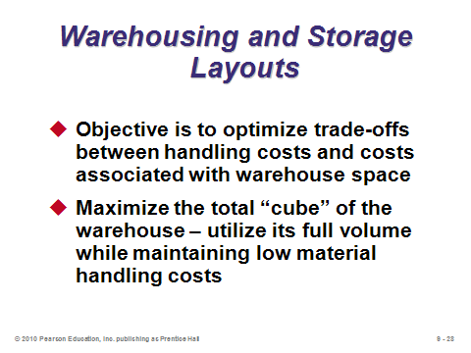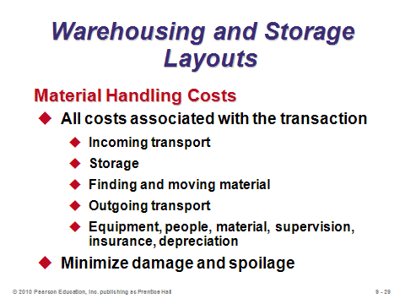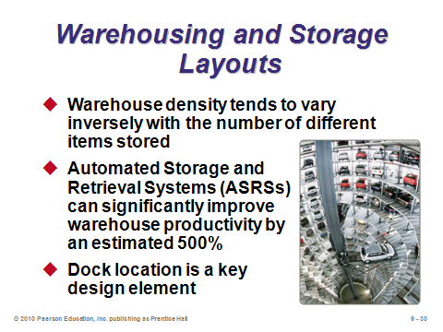

**9-28 9-29 9-30**

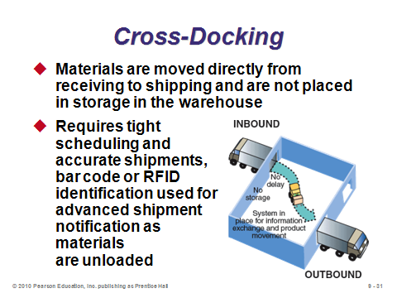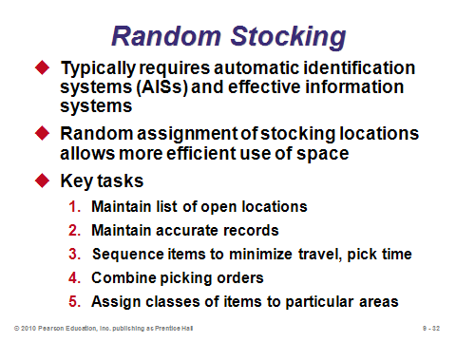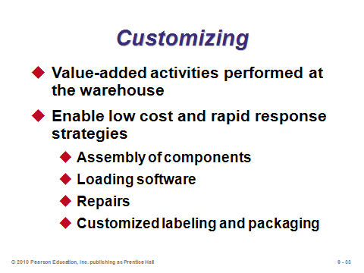

**9-31 9-32 9-33**

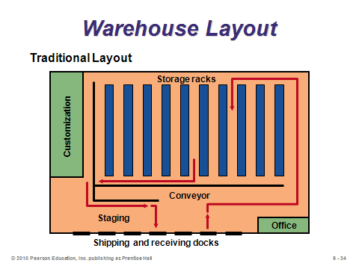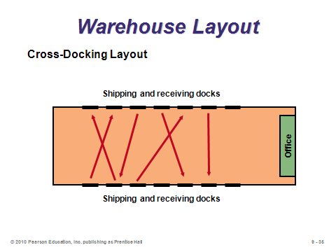

**9-34 9-35**

FIXED-POSITION LAYOUT (9-36 through 9-37)

Slides 36-37: These slides describe the fixed-position layout. It is the obvious choice for certain large products/projects, or for ones where the product itself would be very difficult to move (e.g., the land for a corn farm). For firms managing more than one of these, scheduling and moving workers, materials, and machines can be a challenging task, and it would be possible that more workers and machines would be needed than on a traditional assembly line. Slide 37 illustrates the concept of “manufactured homes,” where much of the structure is made ahead of time on an assembly line and the whole thing, despite its size, is shipped to and placed on its final location.

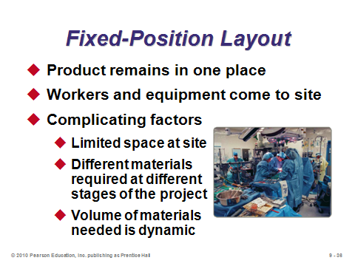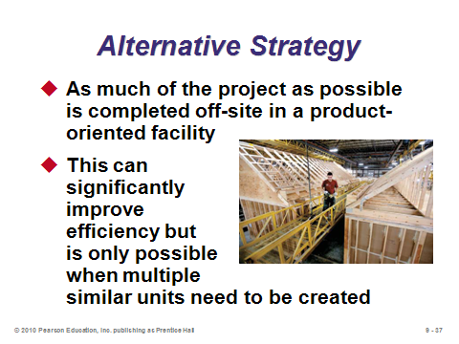

**9-36 9-37**

PROCESS-ORIENTED LAYOUT (9-38 through 9-53)

Slide 38: A process-oriented layout is the layout of choice for a typical job shop, as well as for many service industries (banks, cafeterias, hospitals, etc.). The machine investment costs are typically lower than those for a high-volume assembly line. But labor costs may be higher (due to the necessity for higher-skilled, flexible employees). Also, work-in-process inventory levels are typically higher than for an assembly line.

Slide 39: Figure 9.3 shows hospital layout, which makes much more sense than sending all patients past every department as an assembly line manner would.

Slide 40: This slide illustrates the pod layout at Arnold Palmer Hospital. The central nursing location has saved literally miles of walking per day for nurses as compared to their old layout.

Slides 41-50: These slides take us through Example 1 in the text, which utilizes the load-distance method to design a process-oriented layout. The objective is to arrange work centers in order to minimize total costs of material handling, defined here as load (the number of shipments per unit time) times distance (or cost to move between department *i* and department *j*). Slide 43 shows the steps to follow in designing a good layout. Slide 44 illustrates a *from-to matrix* (Figure 9.4), showing the loads between each station. Apparently, Department 3 should be placed near Departments 1 and 6 due to the high number of loads per week between those Department 3 and those two departments. Slide 45 (Figure 9.5) shows an initial solution, which is hoped to be improved upon. Slide 46 shows the *interdepartmental flow graph* (Figure 9.6) of the layout shown in Figure 9.5. Placing the loads on the arrows provides a good visual picture of potential areas for change (for example, Assembly and Machine Shop should probably be closer together; meanwhile, Painting and Shipping do not have to be that close). Slides 47 through 50 shows how the costs for the initial solution are improved by $90 (16%) after the switching to the second solution (Figure 9.7). Note that for just six departments, there are 6! = 720 possible arrangements to try. For 10 departments? The manager would have to explore 10! = 3,628,800 combinations to be certain of finding the very best!

Slides 51-53: These slides cover computer software, which is usually necessary for large applications. These programs tend to be interactive, and most claim to provide good but not necessarily optimal solutions. Slide 52 (Figure 9.9) shows an application of CRAFT (Computerized Relative Allocation of Facilities Technique). CRAFT systematically tests pairs of departments to see if moving them closer to each other lowers total cost. Slide 53 is a screen shot from e-factory, providing very realistic images of potential layouts.

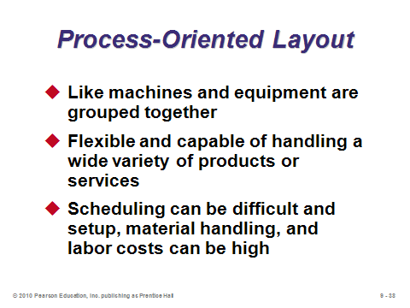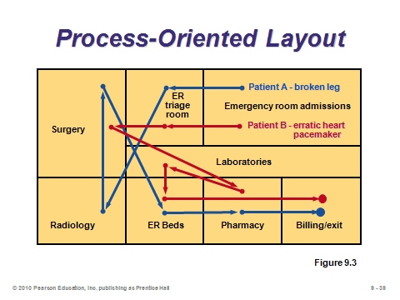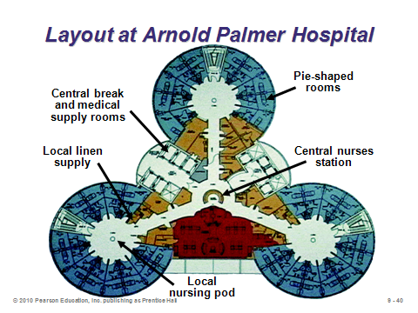

**9-38 9-39 9-40**

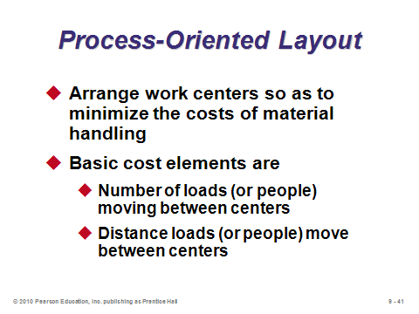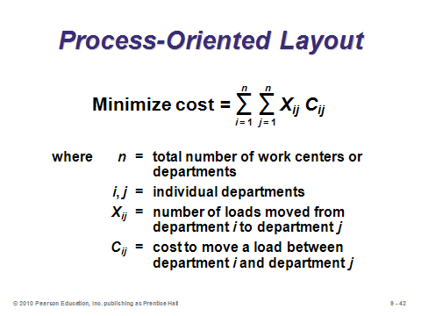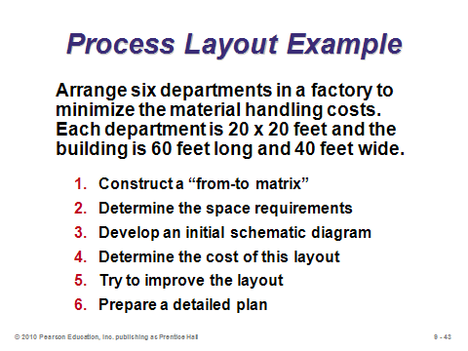

**9-41 9-42 9-43**

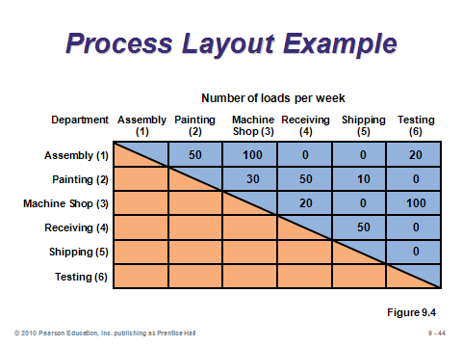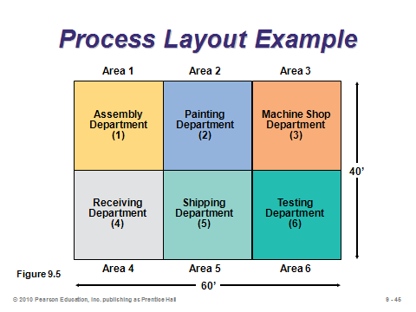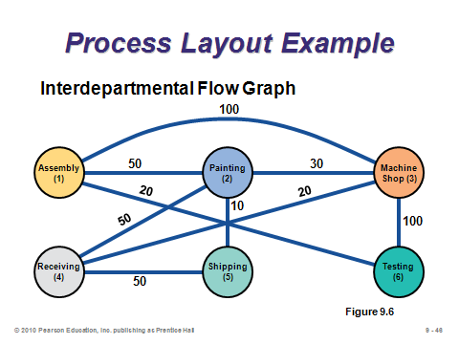

**9-44 9-45 9-46**

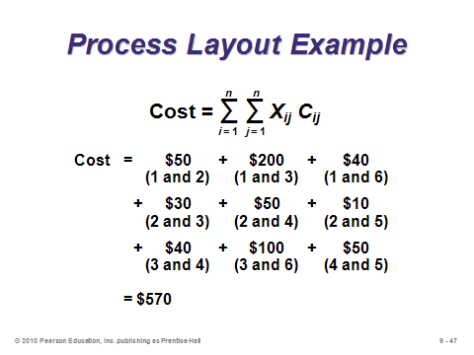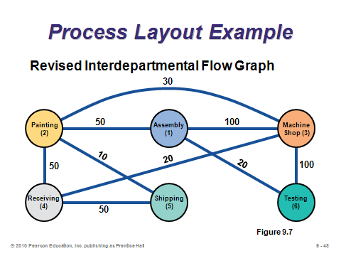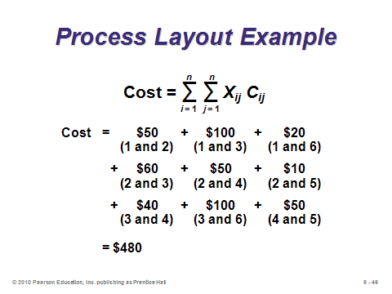

**9-47 9-48 9-49**

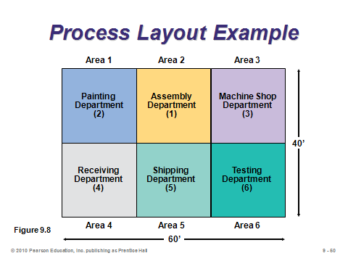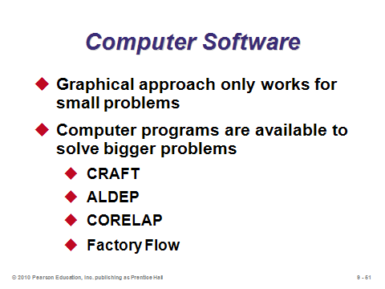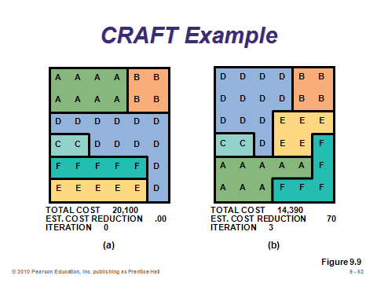

**9-50 9-51 9-52**

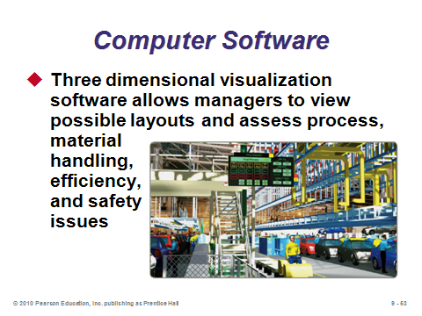

**9-53**

WORK CELLS (9-54 through 9-64)

Slides 54-56: Work cells can often be thought of as “mini-factories,” producing their own products or product groups. Slide 54 describes work cells, Slide 55 lists potential advantages stemming from focusing on one or few items as well as a sense of employee ownership, and Slide 56 identifies the requirements of cellular production.

Slides 57-58: These slides (Figure 9.10) illustrate two different instances where U-shaped layouts for work cells can be effective, particularly when the workers are cross-trained.

Slides 59-61: These slides address the issue of minimum staffing levels for work cells. *Takt time* is the pace of production units to meet customer demands. Slide 59 provides the takt time computation, and once that is known, the computation for the number of workers required. Slides 60-61 illustrate Example 2 from the text. Slide 60 shows the work balance chart (Figure 9.11), which delineates the various tasks and their times necessary for producing the product. The sum of these times equals the *total operating time required* for the product (the numerator of Equation (9-3)). Slide 61 shows that 2.91 (or 3) workers will be required. Note that this implies that one or more workers may work on more than one operation per product.

Slide 62: The staffing level calculation in Slide 59 (Equation (9-3)) assumes that either the time for the bottleneck operation is no more than the takt time or that more than one worker can help with the bottleneck operation. Cross-training of the workers, at least for manual operations, often overcomes minor imbalances in the work cell. However, if the bottleneck operation is machine-driven and has a larger time than the computed takt time, then the bottleneck’s time will determine the pace of production (see Supplement S7).

Slides 63-64: Slide 63 defines *focused work center* and *focused factory*. Slide 64 (Table 9.2) summarizes the three levels of focus discussed in this section of the text and provides an example of each.

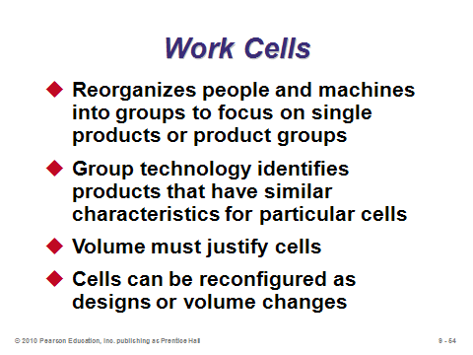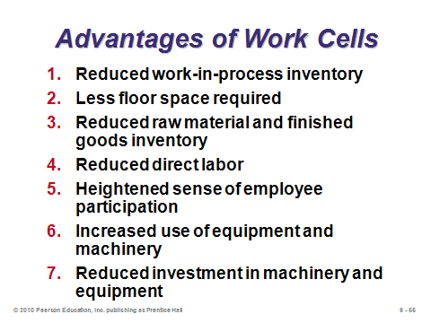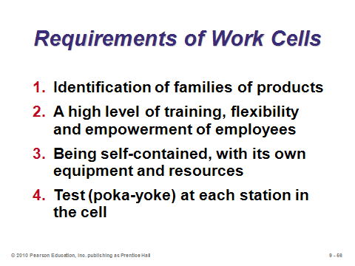

**9-54 9-55 9-56**

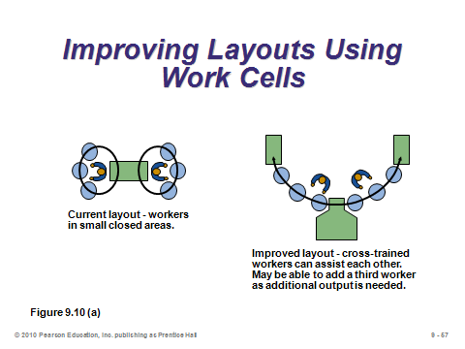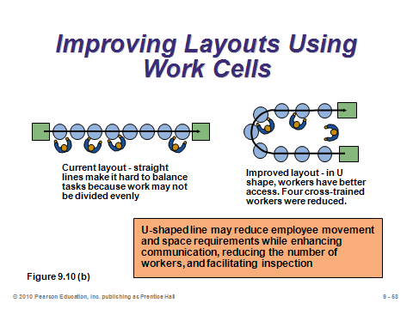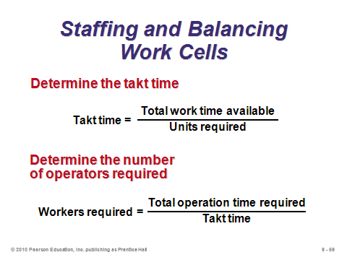

**9-57 9-58 9-59**

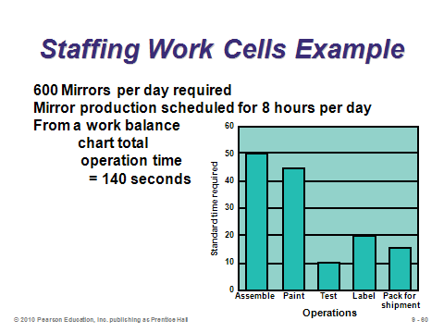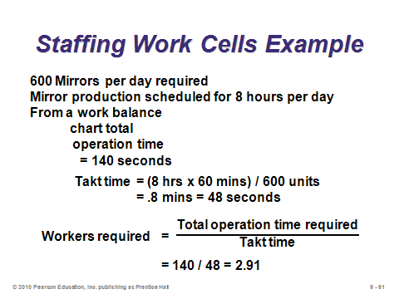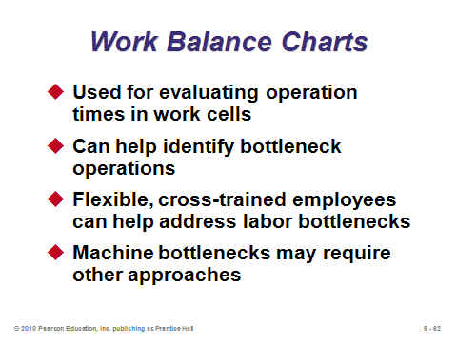

**9-60 9-61 9-62**

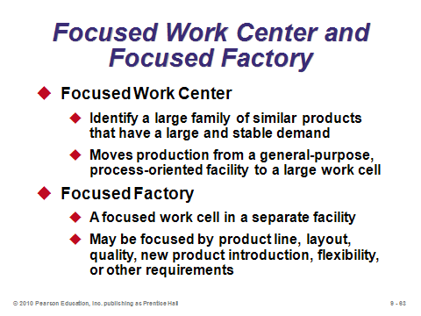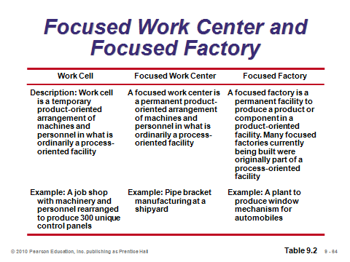

**9-63 9-64**

REPETITIVE AND PRODUCT-ORIENTED LAYOUT (9-65 through 9-76)

Slides 65-67: These slides describe product-oriented layouts, or what students imagine as traditional high-volume assembly lines. These often require a high level of capital investment for the specialized assembly line equipment. Less skilled labor is needed than for a process-oriented layout, implying potentially lower labor costs and less training. However, such jobs may be more boring for the workers, which could lead to morale and absenteeism issues. In terms of layout, the general placement of machines may be relatively straightforward as the order of machines must follow the progression of steps by which the product is made. Products often move down the line via automatic conveyor belts. *Balancing* the line becomes the major task in layout design.

Slide 68: This slide (Figure 9.12) illustrates the McDonald’s hamburger assembly line. Each hamburger goes through the same series of stations.

Slide 69: *Disassembly lines* take products apart. Modern-age products are now being designed with end-of-use disassembly in mind. The Mercedes S-class is 95% recyclable.

Slide 70: This slide identifies the steps in assembly-line balancing. Such an approach assigns multiple tasks to single workstations, in the hope that each workstation will then take approximately the same amount of time per product.

Slides 71-76: These slides cover Examples 3-5, which illustrate a line balancing application for Boeing. Slide 71 (Table 9.3) presents the time and precedence data for each task (similar to the project management tables of Chapter 3 but with times in minutes or seconds instead of days or weeks). Slide 72 (Figure 9.13) presents the precedence diagram. Slide 73 provides the cycle time and minimum number of workstations calculations. Slide 74 (based on Table 9.4) presents five of the most popular heuristics (rules) for assigning tasks to workstations. The Boeing example utilizes the *most following tasks* heuristic. Slide 75 (Figure 9.14) displays the solutions, and Slide 76 computes the efficiency of the line. A high efficiency value would imply little slack time in any of the workstations.

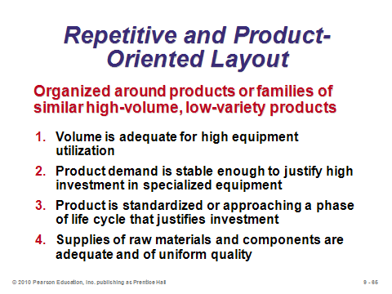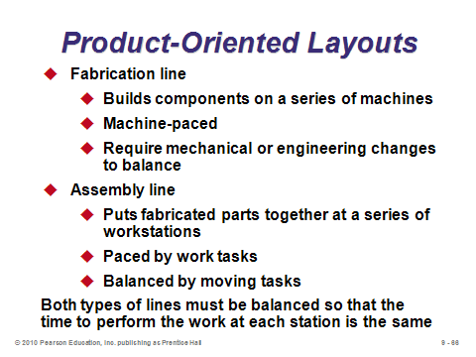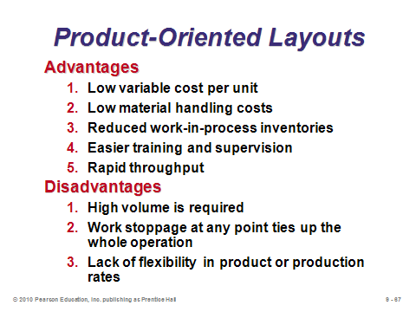

**9-65 9-66 9-67**

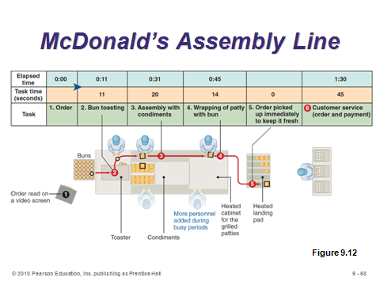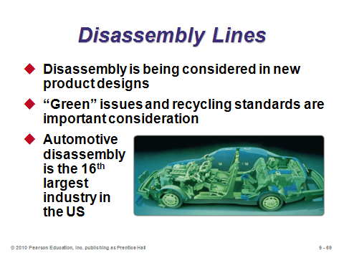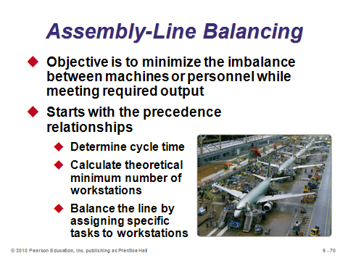

**9-68 9-69 9-70**

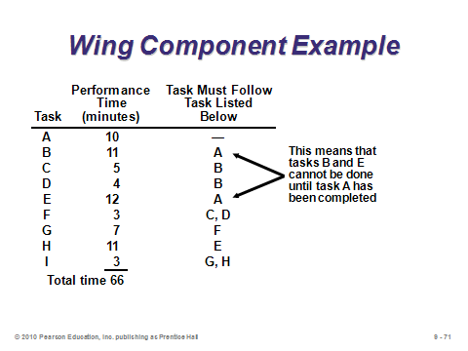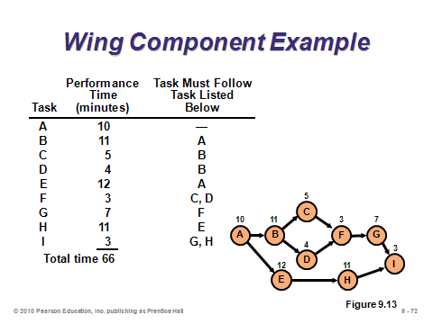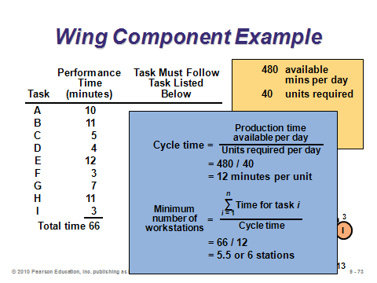

**9-71 9-72 9-73**

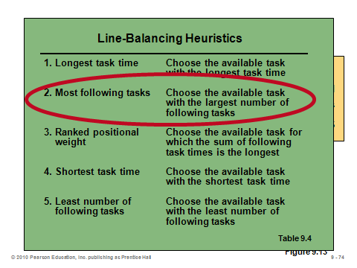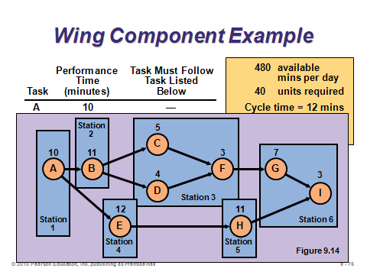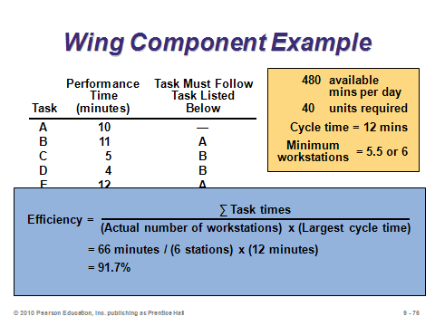

**9-74 9-75 9-76**

**Additional Assignment Ideas**

1. Have the students view episodes of the sitcom *The Office* and comment on the layout, including the location of personnel. Then have them find out what it is like to be a white collar worker in a large Japanese firm such as Toyota. The students will likely discover offices with hundreds of people in one room with no partitions, walls, or offices—very depersonalizing.

2. Many warehouses are happy to grant tours to student groups. Either provide a class tour of a local warehouse, or ask the students to visit warehouses themselves in small groups. (If nothing else, most likely the university campus itself has several warehouses.) Ask the students to write up a report about the warehouse layout, with emphasis directed towards the issues raised in the text. In particular, does the warehouse use forklifts, automatic guided vehicles, or ASRSs? Does it practice cross-docking, random stocking, or customizing? Where are the docks located, and are they dedicated to certain functions, shipment types, or shipment companies? Do the docks serve as inbound only, outbound only, or both? How is inventory stored on the shelves? How high do the shelves go? How are goods picked from the shelves? How automated is the whole warehouse system?

3. Review any two of the Web sites listed below and describe the layouts represented. Some may have multiple types.

Boeing: http://www.boeing.com/companyoffices/aboutus/tours/index.html

Honda: http://corporate.honda.com/america/facilities.aspx

Manufacturing Engineering: www.mfgeng.com/pjappar.htm

**Additional Case Studies**

Internet Case Studies (www.pearsonglobaleditions.com/heizer)

* *Palm Beach Institute of Sports Medicine*: Deals with all aspects of laying out vacant space for a fitness center.
* W*&G Beer Distributorship*: Involves layout of a warehouse that distributes beer.
* *Microfix, Inc*.: This company needs to balance its PC manufacturing assembly line and deal with sensitivity analysis of time estimates.
* *Des Moines National Bank*: This recently completed building needs to arrange its departments to optimize efficiency.
* *Collier Technical College*: School must decide which of two buildings meets its expansion needs.

Harvard Case Studies (http://harvardbusinessonline.hbsp.harvard.edu)

* *Toshiba; Ome Works* (#696-059): Deals with the design of an efficient notebook computer assembly line in the Ome, Japan factory.
* *Mouawad Bangkok Rare Jewels Manufacturers Co. Ltd. (A)* (#696-056): The small Thai factory faces a challenging production control process.
* *Copeland Corp. (B)* (#686-089): A plant layout must be selected from two alternatives available to this Sidney, Australia manufacturer.

Richard Ivey School of Business (http://cases.ivey.uwo.ca/cases/pages/home.aspx)

* *Canadian Tire Check-out Configuration* (#9B04D006): The vice-president of store planning and merchandising was evaluating checkout configurations. He needed to make his decision soon to avoid delaying the construction of four new test stores. He has three options; continue using the current tandem system, add self check-outs or switch to a single line configuration. He must analyze the three options to determine the benefits and trade-offs of each.

**Internet Resources**

|  |  |
| --- | --- |
| Commercial layout software from Cimtechnologies | www.cimtech.com |
| Factory flow for layout analysis | www.ugs.com |
| Layout: iQ | www.rapidmodeling.com |
| Proplanner’s Flow Planner calculator | www.proplanner.com/product/details/flowpath.aspx |
| Various facility design plans | wwwl.manufacturing.net |

**Other Supplementary Material**

Learning Game

* Fish, L. (2005). Teaching Assembly Line Balancing: A Mini-Demonstration with DUPLO® Blocks or “The Running of the Dogs *Decision Sciences Journal of Innovative Education*, 3(1), 169-176. This develops a student’s understanding of assembly line balancing quantitatively and qualitatively. Assembly lines issues, such as bottleneck and unbalanced workstations, quality, task times, product assembly, and space allocation are presented.

Videos

Film available from:

Society of Manufacturing Engineers

One SME Drive

P.O. Box 930

Dearborn, Michigan 48121-0930

(P) 313-425-3000

(F) 313-425-3412

http://www.sme.org

* *Layout Improvements for Just-in-Time*: See how three manufacturing facilities have maximized plant floor space efficiency to eliminate waste, improve delivery and performance, increase inventory turnovers, and reduce cycle time. Order # PI-VT393-3456

Film available at http://webserver.lemoyne.edu/~wright/planes.htm

* *Balancing Planes*. Ammar, Salwa and Ronald Wright. Le Moyne College, Syracuse, N.Y. (Additional material from Drs. Ammar and Wright is available at: http://web.lemoyne.edu/~wright/learn.htm )

Commercial Software

* FactoryCAD, FactoryFLOW, Plant Simulation

UGS Tecnomatix Plant Design and Optimization enables the modeling and simulation of

production systems and process. By enabling engineers to see the outcome of plans in

virtual plants, organizations avoid wasting resources fixing problems in real plants.

USG Tecnomatix (part of Siemens)

5800 Granite Parkway, Suite 600

Plano, Texas 75024

(P): 800-498-5351

http://www.ugs.com

Models

*Distance*

For models that use distance measures, actual distance should be used when known. However, if such data are difficult to obtain or keep track of, distances can be calculated based on (*x*, *y*) coordinates. Students should be familiar with the Euclidean (straight line) distance formula from high school for the distance between two points (*x*1, *y*1) and (*x*2, *y*2):



Often, however, particularly in office buildings, retail stores, and warehouses, travel occurs in rectangles (north-south and east-west), as opposed to straight lines (e.g., climbing over office cubicles). The formula for the rectilinear distance between two points (*x*1, *y*1) and (*x*2, *y*2) is:



*Single-dock warehouse problem*

A simple greedy algorithm exists for the problem of where to stock items in a warehouse that only has one dock for pickups and deliveries and the objective is to minimize average distance traveled. This is a “bang for the buck” approach. To solve the problem, first divide the warehouse into blocks of storage area (such as storage shelves). Then for each type of item that will be stored in the warehouse, calculate the ratio of average number of trips (the bang) to blocks of storage area needed (the buck). The blocks of storage area needed would presumably be based on the maximum inventory level for that item (in an EOQ environment this would be the size of the incoming order). One-by-one, place the items as close to the dock as possible in decreasing order of their ratios. In general, items that are visited frequently should be placed near the dock; however, items that take up a lot of space should be placed further from the dock so that other items can be retrieved quicker (i.e., there is an opportunity cost for taking up a lot of space near the dock with only one type of item).